Weekly Hands-On Exercise 1

Design Patterns –

1. Implementing Singleton Pattern

* Singleton.java

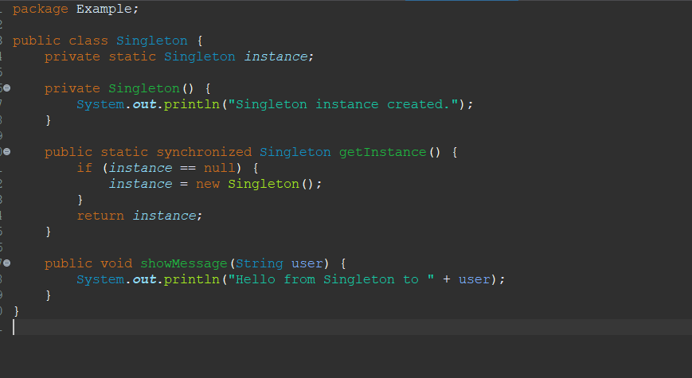

* UserA.java

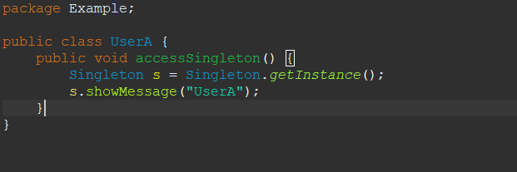

* UserB.java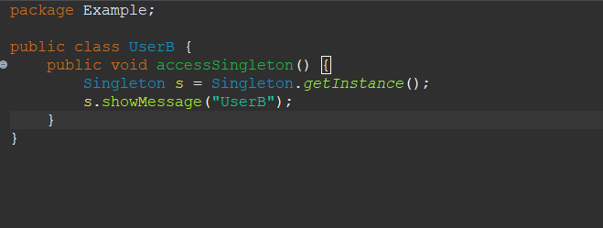
* Main.java

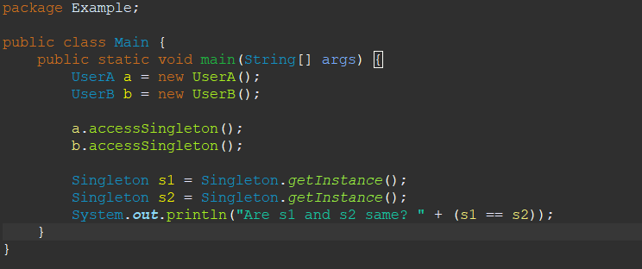

Output-

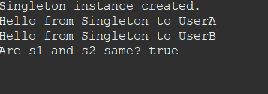

1. Implementing Factory Method Pattern

* Main.java

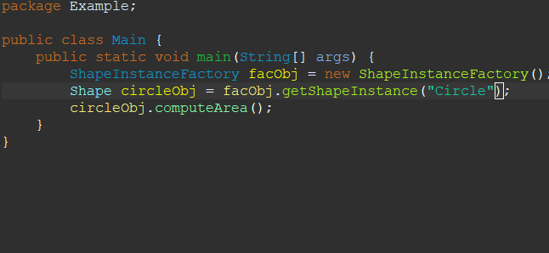

* ShapeInstanceFactory

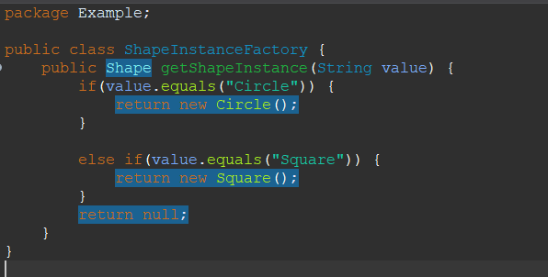

* Circle

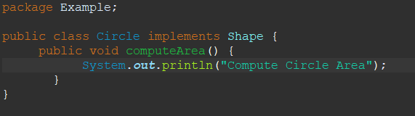

* Square.java

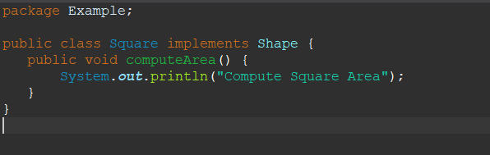

* Shape.java

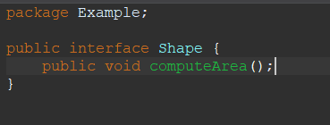

Output –

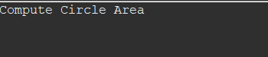



Data Structures and Algorithms –

1. E-commerce Platform Search Function

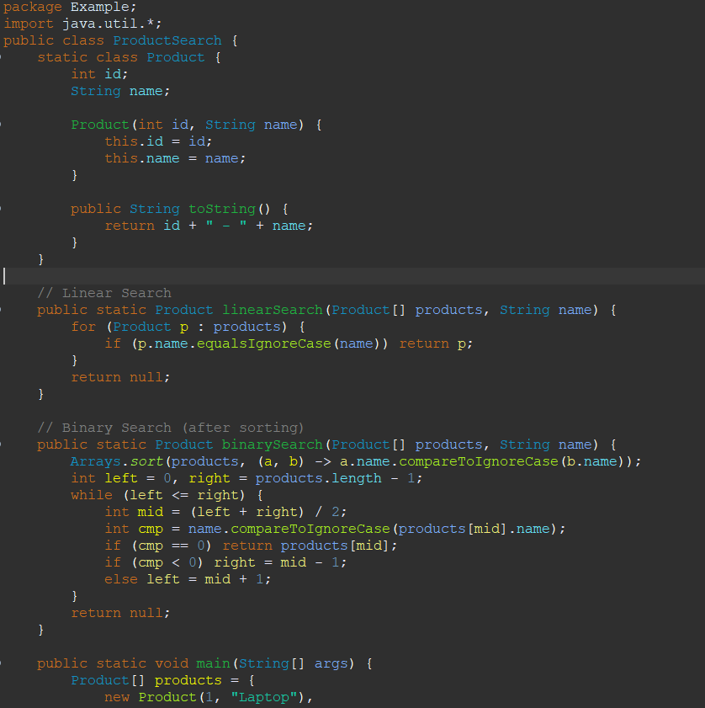

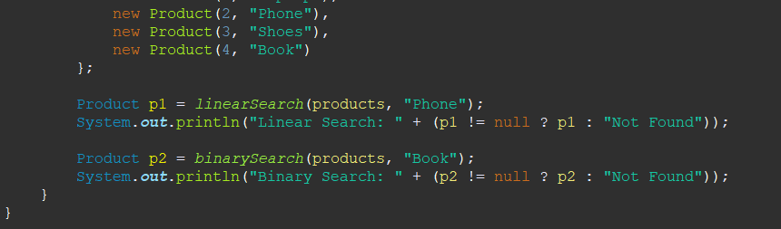

Output –

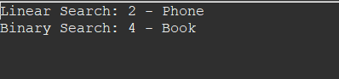

1. Financial Forecasting –

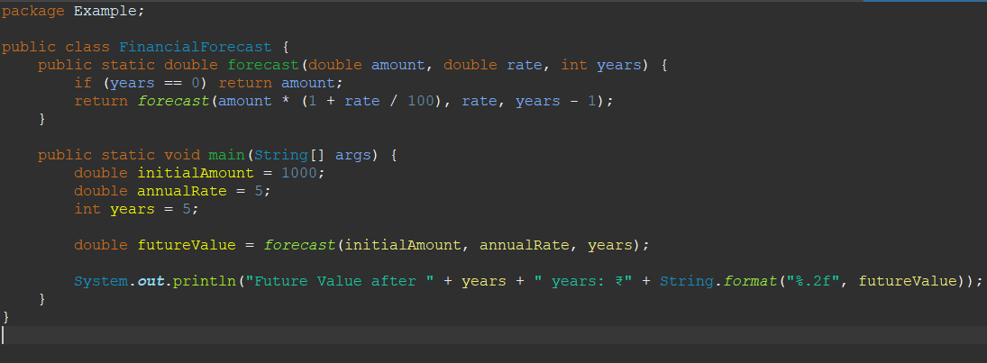

Output –

Screenshot 2025-06-20 192654.png